**18CSC305J: ARTIFICIAL INTELLIGENCE**

***EX9- IMPLEMENTATION OF UNCERTAIN METHODS FOR AN APPLICATION***

**AIM:** To implement uncertain methods for an application (Monty Hall problem) using Python.

**PROBLEM:**

Assume that a room is equipped with three doors. Behind one is a prize. The user is asked to pick a door and will win whatever is behind it. After picking a door and before the door is opened, however, someone who knows what is behind the doors (Monty Hall) opens *one of the other* two doors, revealing no prize, and asks if the user wishes to change the selection to the third door (i.e., the door which neither the user picked, nor he opened). The Monty Hall problem is deciding whether the user does it.

The correct approach is for the user to switch. If the user does not switch, the expected chance of winning is 1/3 since no matter whether initially the user picked the correct door, Monty will show a door without the prize. But after Monty has eliminated one of the doors, the chances of winning do not improve to better than 1/3 by sticking with the original choice. If the user switch doors now, however, there is a 2/3 chance of winning.

**CODE:**

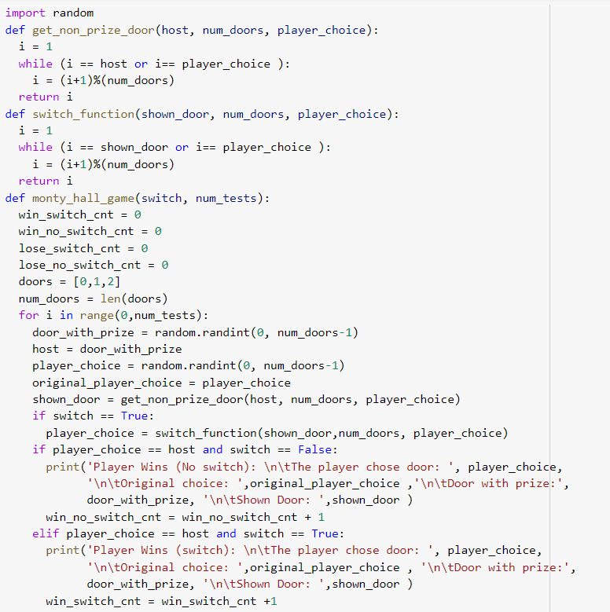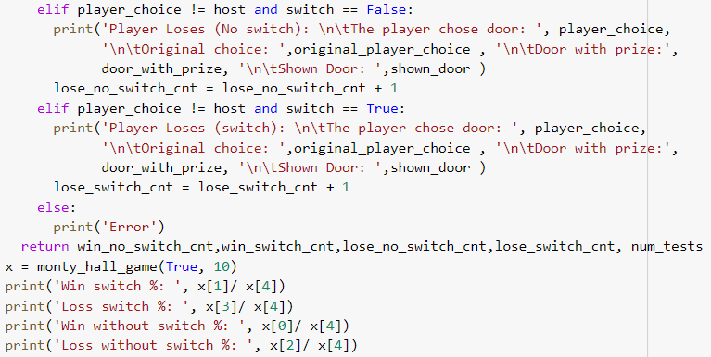



**OUTPUT:**

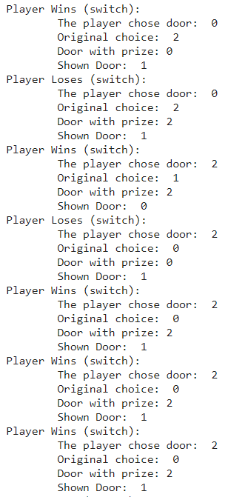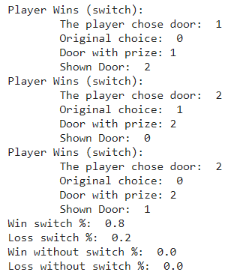

**RESULT:** The code for implementing uncertain methods for an application (Monty Hall problem) was written and executed in Python successfully.